My application - named PasskeyGenerator - will welcome users to generate and input a password, to which the application will determine its validity. The user will begin by selecting a button to generate a random passkey (four integers). Next, the user will enter this passkey into a supplied text field and will select a button to check the validity of the passkey entered. If the passkey is valid, a bottom-most label will set text to “Valid!”; otherwise the label will set text to “Invalid.”

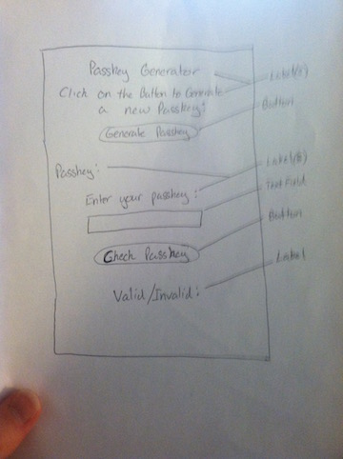

<PasskeyGenerator>

<label title = “Passkey Generator”> PasskeyGenerator </label>

<label title = “Click on the Button to Generate a New Passkey”> PromptLabel </label>

<button title = “Generate Passkey”> GeneratePasskey </button>

</linebreak>

<label title = “Passkey:”> PasskeyLabel </label>

<textfield> UserInput </textfield>

<button title = “Check Passkey”> CheckPasskey </button>

</linebreak>

<label title = “Valid/Invalid:”> ValidityCheckLabel </label>

</PasskeyGenerator>